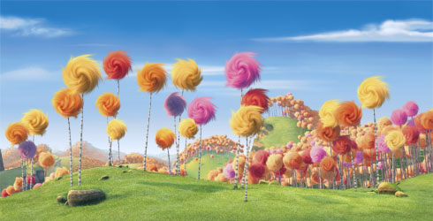

**I am the Lorax.**

**I speak for the trees.**

**I spreak for the trees,**

**for the trees have no tongues.**

**I meant no harm.**

**I most truly did not.**

**But I had to grow bigger.**

**So bigger I got.**

**UNLESS someone like you**

**Cares a whole awful lot,**

**Nothing is going to get better.**

**It's not.**

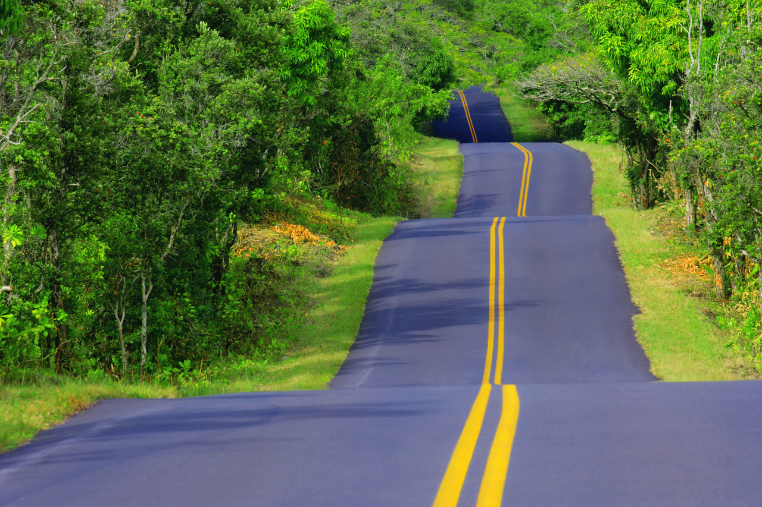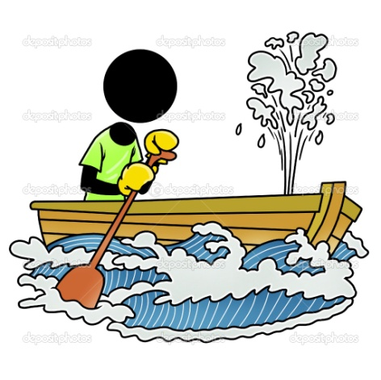

**My beard grows down to my toes,**

**I never wears no clothes,**

**I wraps my hair**

**Around my bare,**

**And down the road I goes.**

Money money

Is going to get me a girl

Money money

I am going to use it to buy me a cup of coffee

Money money

Is going to take me to Paris

Money money

Is going to buy me some new clothes

Money money

I am going to use it to do my laundry

Money money

Is going to buy me some groceries

Money money

Is going to fix my house

Money money

Is going to send me to the rich men’s world

Money money is going to buy me a cellular phone

C:\Documents and Settings\User\Local Settings\Temporary Internet Files\Content.IE5\LYDW7K2I\MC900197467[1].wmfC:\Documents and Settings\User\Local Settings\Temporary Internet Files\Content.IE5\LYDW7K2I\MC900197467[1].wmfC:\Documents and Settings\User\Local Settings\Temporary Internet Files\Content.IE5\LYDW7K2I\MC900197467[1].wmfC:\Documents and Settings\User\Local Settings\Temporary Internet Files\Content.IE5\LYDW7K2I\MC900197467[1].wmfC:\Documents and Settings\User\Local Settings\Temporary Internet Files\Content.IE5\LYDW7K2I\MC900197467[1].wmf-Aldo Kraas

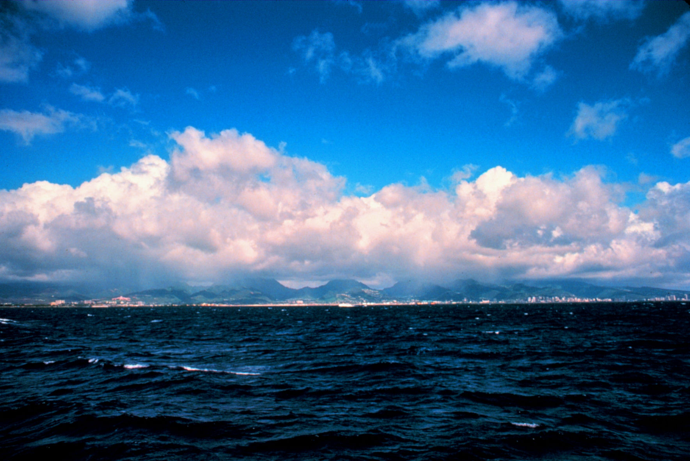**I am outgoing and determined**

**I wonder what my life will be like**

**I hear people talking**

**I see a volleyball court**

**I want a St. Bernard puppy**

**I am outgoing and determined**

**I pretend to know what I’m talking about**

**I feel butterflies in my stomach**

**I touch the blankets on my bed**

**I worry about growing up**

**I cry when I watch sad movies**

**I am outgoing and determined**

**I understand life isn’t always easy**

**I say we should live with no worries**

**I dream about a better world**

**I try to understand why things happen**

**I hope people don’t judge me**

**I am outgoing and determined**